Dictionary Management
> Problem Statement:

The captions and messages, which we call "dictionary", used in our products
are now in state of confusion.

There're so many products, for example HR series has 3 products,
that is, CJK, CWS and CSR, and each product has their own way
to manage the captions and messages. That means each product
has their own database table, and each has different key columns.
And adding to that, lack of sufficient communication with each other
caused the situation that some "dictionaries"are slight different
between the products.

And what is worse, WAP has been heading for global market and
each product separatedly tried to translate their "dictionaries"
in some way. Some products decided to asked a company to translate
their "dictionaries", other products tried to translate their "dictionaries"
on their own, using developers who know the product well.

Against this confused state, we wants you:
- to unify each "dictionaries"
- make it easy for everyone in every department(**) to use "dictionary" data

(**) e.g. sales, consultants and of course development departments

[Constraints]
Server-side programming language: Java (You can use OSS libraries like Spring)
Database: Oracle

> Solution:

The solution for this problem is to unify the dictionary tables into a single database and provide a common method of access, so that a anyone in any department or outside of company (Ex. Customers, partners) can access the dictionary in easy, secured, reliable manner.

> Why do we need this solution :

As per the current database scenario of company, the dictionaries for all the products are scattered and their tables are not arranged efficiently to manage the translation of every dictionary. There is no any unified platform to access the dictionaries by anyone who needs the them.

> How we can do it:->

The basic idea to reduce memory requirement by each dictionary table is to reduce the redundancy by storing the caption columns only once for all languages. To provide the secured access levels that will decide to let a person access the specific requested table or not.

> System platform:

The system will be deployed as web service.
When user performs any operation, the system will exchange data with the server. The Server will contain a single unified database containing all the dictionaries. A link will be provided between our server and main user database.

> Requirements of the system:

    - A server with some space: The system will require a server with space proportional to the number of dictionaries and their translation dictionaries available.
    - A local system with network connection : The user would need a local system with internet connection, so that the system can exchange data with the server.
    - The user category information : The system will require the category of the user trying to access the dictionary in order to decide his access level. Suggestion: This can be done by comparing the user id in main user database and to get his category but that will require main user database access. And also while providing the access to some specific individual we will require the main user database access to select individuals.

> Merits of the system:

1.
Business before:
All of the dictionary table were scattered and there was no any unified database for dictionaries.

Business after:
Now we can have the unified database to manage all dictionaries on one platform. Which make it easy and enables us to provide the global access to users.

2.
Business before:
The size of the database considered was quite large and there were many tables for different language versions.

Business after:
Now we have reduced the size of the database by storing the all the language versions in single table and not repeating the captions for all versions.

3.
Business before:
There was no any functionality of updating or accessing the dictionaries by not-technical people. They always have to depend on technical person for it.

Business after:
Now any person can access and update the whole dictionaries via single web platform without having the knowledge of database or its structure.

4.
Business before:
There was no any system to control the access for different category of peoples like customers, engineers, administrator.

Business after:
We have added the feature to control the access and update authority. Now we can control access and update feature on individual level.

5.
Business before:
Due to lack of sufficient communication with each other caused the situation that some "dictionaries" are slight different between the products.
Business after :
we can now reduce the database size by simply storing only one united table for this case.

> How we guaranty the correctness of our system :

After finishing each module of our system, we will write tests for the respective module, to check if it works fine. We will also write tests to ensure that this module doesn't affect the other modules.

After we develop the complete system, we will write tests for the whole system. We will follow the method of regression testing, to ensure that the changes that we include to fix the current bug, doesn't introduce new bugs.

The current dictionary database management team will also be consulted to ensure the correctness of our system.
> Detailed explanations and merits of all the functions:-

FUNCTIONS:

1.) AddDictionaryTable (Priority : high)

Operation:

a. This is the most important function in our project.
b. Only the dictionary database managers and project employees related to dictionary, having the knowledge of dictionary will be able to add this table in our database. We will also maintain the metadata that will contain the information about all the table as one row per table .
c. We will initially ask user the various parameters as follows and these will added to a metedata table in tuple corresponding to current table:
        - Table name
        - Table Description
        - No. of caption columns
        - No. of messages columns
        - product description
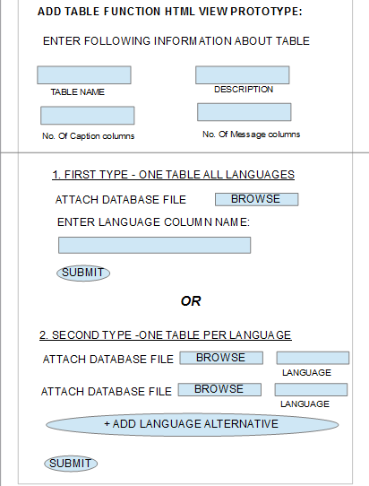

d. We will ask user if there are language alternatives are present as different tables or in same table.
e. We will ask user the language column name or number if the language alternatives of table are present in same table.
f. And if user selects that they are present in different table then we will ask him to input the different language tables files as we will provide him an option to add a new language table and we will also ask him the respective language in which table is present.
g. If the user selects option of language alternatives of table are present in same table, we can identify the different languages by language column name or number. Then we will simply add the number of set of message columns equal to number of languages and copy the language message attribute values to these respective column set from the rows. After this we delete all the rows that has been copied, below the first language.
h. If the user selects option that language alternatives are present in different table then we will simply add the number of set of message columns equal to number of languages and copy the language message attribute values to these respective column set from the respective tables.
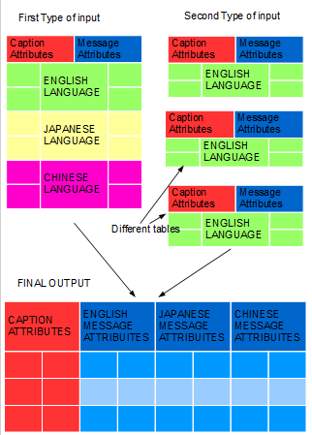
i. After doing the above procedure the message attributes values that belonged to different languages will be stored as new set of columns and and the a new table will be formed with single set of caption attribute values and many sets of message attribute values corresponding to different languages. We will keep track of the language sequences in which message attributes are stored by an multivalued attribute in metedata table.
j. We will also take input regarding the access levels of the specific table. We will create two tables regarding the access of the database: The category table and the individual table.
k. The category table: This will consist of following attributes that are related to the person trying to access the table:
1)category 2)product 3)set of message attributes(boolean) 4)individual access(boolean).
Category – the category to which the user belongs.
Product – the product to which user belongs.
Format File – Format that is demanded by different category. This format will be used to show the data accordingly their mapping and is decided by the needs of the specific persons. This can be edited
by the visual or graphical tool and hence anyone from category can edit it.
Individual access – this will be true if the user wants to add the access to the table at individual level for the specific category. So if it is true we will have to look into individual table to see if the person is present there.
l. The individual table: this will consist of the list of individuals only who can access the table. Consist of following attributes:
1)Category - the category to which the user belongs.
2)Product - the product to which user belongs.
3)User ID – The user id of the person.
The attributes category and product may help in indexing if we want to make search fast over long list of individuals.
m. The category table and individual tables will be inputted by the dictionary management administrator.
n. The update access levels will also be needed . To determine the who can update the tables. The mechanism for this will be same as that for access level.
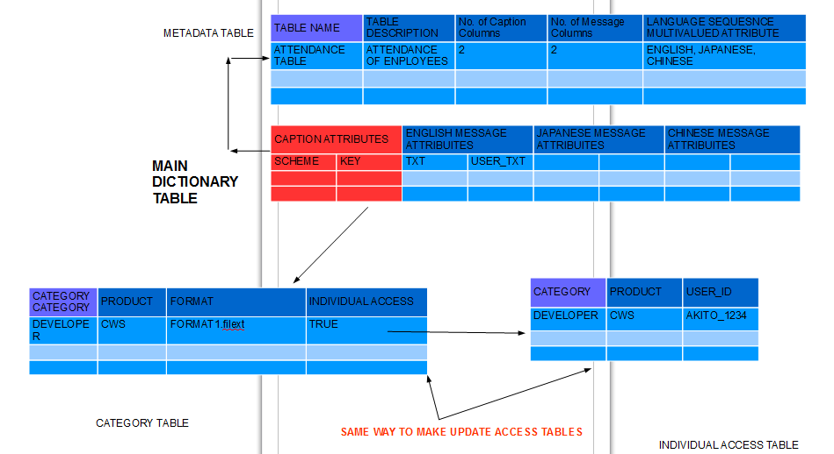

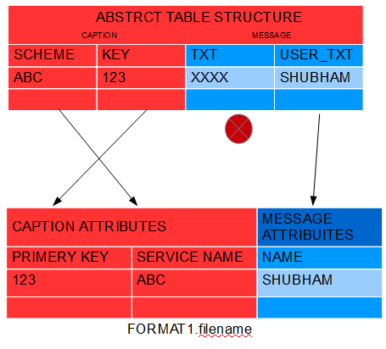

n. The update access levels will also be needed . To determine the who can update the tables. The mechanism for this will be same as that for access level.
Merits:

- The main advantage of this technique is that it is saving the space as the caption attribute values are not repeating for every language translation. Initially this thing was making the database size bigger and obviously as size increases the memory management and accessing data by searching gets more difficult and time taking.
- The structure of the dictionary table gets more systematic and simplified. As we can manage all the translations in a single table and do not need many tables for them.
- The provision for access level is done at this level. So that security and authentication at individual level can be provided.
- We can even rearrange all the columns and rename them as per user requirement and can store them without any change in main abstract table as it is just a format. So it wont require much memroy.

2.)SearchData (Priority : high)

Primary Search functionality
a. We can simplify our search data function by assuming that user related to specific product will be shown a list of tables corresponding to that product so that user wont have to type or search it again and again.
b. If he can find the table in list then he can select the one from it.
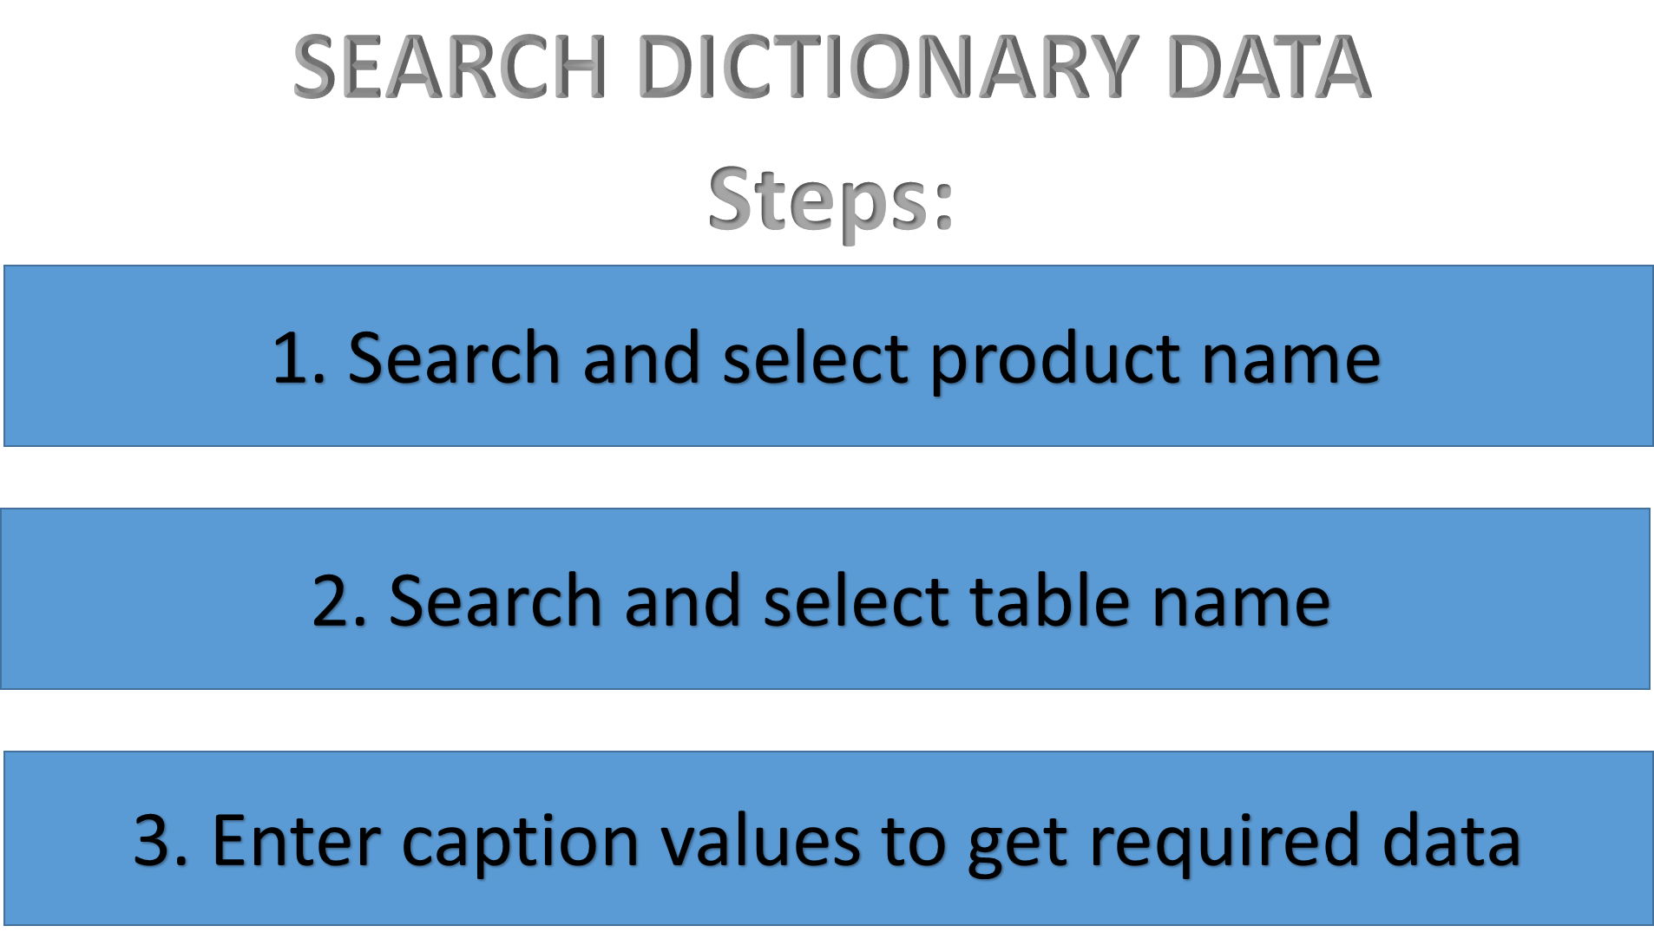
Operation:

The user can search the data in following way:
- First he will enter the product name with which he is concerned with. Any user trying to access the data will obviously know the product name of the data he wants. We can add search functionality like keyword-description if there is the possibility of not knowing product name.

- Then he will enter the table name if he knows it or he can also find the required table by simply searching by some keywords. First we will check the if the input from the user matches any table name and if it does not we will search the given keywords in table descriptions.
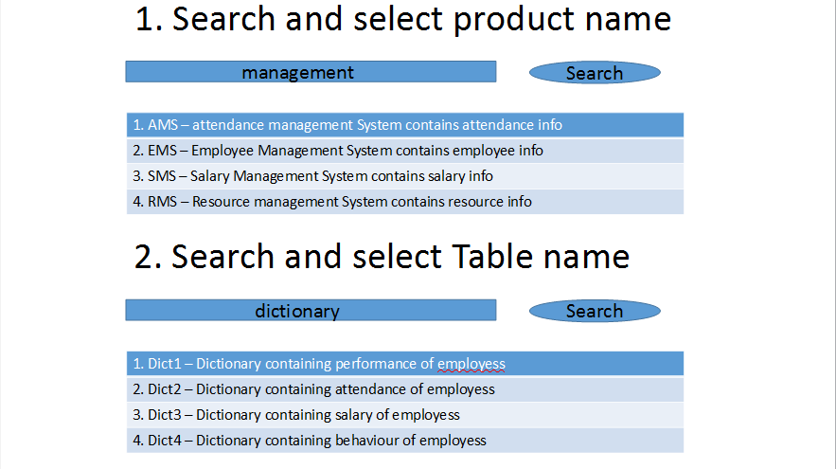
- We will show user the list of table matching as per the name or description and user will have to select one of the table from them. We will also show him the list of the languages in which the table is present and user will have to select the specific language. We can fetch the languages in which the table is present from metadata of the table.
- After selecting the table we will make him enter the caption attribute values. After this we will check if the user can access the table or not by category table and individual table and if he can, then we will show him the message attributes values as per the category table.( By checking which values are true in category table).
- We will show him all the message attribute values that are matching the caption attribute values given by him.

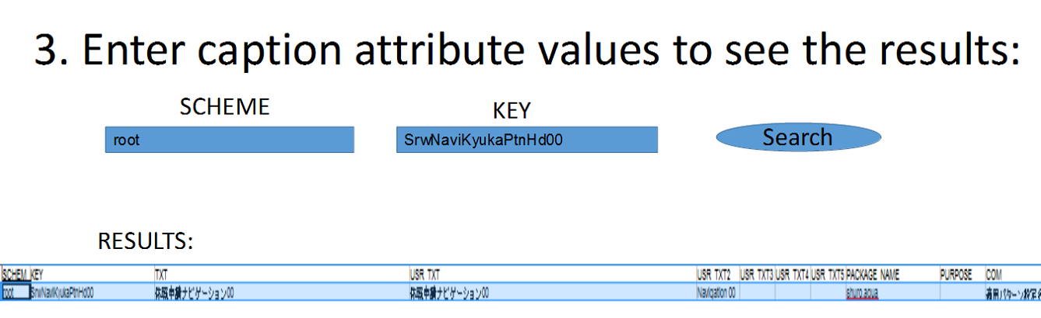
Partial search : The user can also perform partial search by simply entering some caption attribute values and leaving other values empty so that all the results matching the values of the entered attribute will be shown.

Merits:

1. Provides the simple and single access interface for any dictionary present in company
2. An user with no any knowledge of table can also search it by keyword-description search.
3. Partial searching enables the user to search the result only with known variables.

3.)UpdateData (Priority : high)

User can update the specific attribute values in same way that he is accessing or searching the individual attributes and tuples by initially searching them and then updating them. But we will provide the following new methods to operate on rows or columns but we will have to select the table first:
- Add a new row: the user will have to add new rows that will contain all the sets of message attribute values.
- Add a new column: He can add an extra column for caption directly but to add for message, he will have to add the columns for every language and also he will have to update, access levels and `update access` levels.
- He can delete the rows and columns if he wants, he will have to update, access levels and `update access` levels.
- The table can also be deleted but for that he will have to delete the corresponding metadata entry and also the related access and update access tables along with it.
- The new table can be created by simply creating it separately and then adding it by add function.
- We can even allow user the query prompt if he has the administrative access so that he can simply manage database by database queries.
- UPDATE AT MANY AT ONES: For updating many entries in system at one time user can simply add the new updated table in this option. So our system will detect the change in attribute values and update at necessary positions. To use this thing user will first have to search and select the required table and then choose this option.

Merits:

1. Whole data can be accessed and updated at simplified and single interface

4.) DisplayContents (Priority : medium)

Operation:

whole process of displaying contents will be done by html or any display interface. All the oprations can be performed on it. No any technical knowledge is necessary as visual access will make procedure simple for customer or other non-technical peoples.

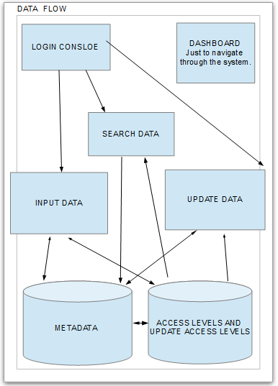
5.) ExportResultsList(Priority : medium)

Operation:
User can also export the result he has got in csv or similar file format.

Merits:
He can operate on data separately and satisfy his own goals. By his own goals means if someone wants to take the given table and update it separately(for example in his own system), he can simply export the file and perform operation that he wants and update the system by again inserting that table into the system. Example: If Mr. xyz wants to perform an division operation on a particular column, he can export the file and take that file to his own system and the he can perform the division operation and update the given table in the main system by simply in using UPDATE MANY AT ONES option. This leads to user friendly feature of the system.

6.) SlightlyDifferentTables: (Priority : medium)

Operation:
We have also got the data tables that differ very slightly in problem statement. So we can create a functionality that will check this kind of change and will prevent system from adding the whole new table into system. We can define the steps as follows:
- First user will have to check the similar tables that are already present in database.
- So we will first create the `similar` group of tables that has same no. of caption and message columns as that of our table.
- Then we reduce this group size by matching the column names with column names of our table. So if the column name doesn't match we will remove that table from `similar` group.
- And then we will compare our tables attribute values with attribute values of tables within `similar` group. If the no. of values that differ in these, do not exceed a specific threshold we will simply update in the `similar` group table by adding the new entries into it, that differ.
- We will perform these task on separate threads (to reduce system load) and keep track of data integrity.

Merits:
This will reduce the overall database size considerably if there are many tables with slight difference are present.

FUTURE SCOPE OR WORK:
We can provide a feature of restricted database terminal according to access level of the user so that any user can directly manage the data by queries.
We can also provide a feature of automatic translation by using some apis like google translate to convert the data into other languages without the help of the translators.

Thank you
Shubham Satish Baldava

Works Applications Co. Ltd.
COMPANY Web Service
Software Engineering Interns

